Luke Charley
Miller Elementary School
Jessica Paulson- 1st Grade.
February 2014

The King of –ing
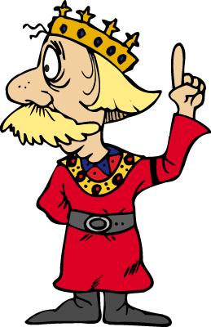
Grade Level: 1st Grade

Subject(s) Area: Language Arts- “King of –ing”

Materials Needed:
- Spring in the Kingdom of Ying book.
- Colored construction paper strips
- Yellow crown cut-outs
- Glue
- Markers and crayons
- Smartboard

Standards:
- Key Ideas and Details
RL.1- Ask and answer questions about key details in a text.
- Phonological Awareness
RF.2- Demonstrate understandings of spoken words, syllables, and sounds (phonemes).
- Phonics and Word Recognition
RF.3- Know and apply grade-level phonics and word analysis skills in decoding words
Objectives:
- Students should know what words end in –ing.
- Students should be able to write out their own –ing words after going over the book together.
- Students should be able to correctly pronounce the –ing ending of words.

Learning Activities:
- Students will gather on carpet for a reading of the book, Spring in the Kingdom of Ying.
- Students will be asked to listen for –ing words to discuss when the book is finished.
- After reading the book, the students recall as many –ing words as they can and these are written on the smartboard.
- Students then go back to their desk to write out several –ing words on a colored strip of construction paper.
- This strip is to go around their head to make their crown to be king or queen of the kingdom of Ying.
- After the students have completed their crown, they gather back onto the carpet for another reading of the book.
- This time, students are asked to clap once or raise their hands when they hear an –ing word.

Assessment:
- Students will be able to identify –ing words in the text.
- Students will be able to write out their choice of –ing words on their crown.
- During the second and final reading of the book, students will participate in identifying any –ing words, and any other –ing words that they can think of that may not be in the book.

Reflection:
I feel like this lesson went very well. While reading the book, the students were able to pay close attention to recognizing when “-ing” words were present. The reading of the book went well, and the transition from the book to the activity of the crown making seemed to go smoothly. After the students began creating their crowns, some of them ended up finishing before the others, and I did not have any instruction in place for them to do if they were done first.
When I recognized this, I had the students that were done first go and help other students who may need help coming up with different “-ing” words to write. This helped them keep them busy and helped me to manage the classroom a lot easier.
In future lesson plans, I will be sure to include activities and directions for the students, especially for younger students, after they may be finished with the activity being completed in the classroom.

